WVU Defend the Republic
Code Documentation

Spring 2024

Index

Attacker Blimp
Overview
Nodes
Detect_cpp
Balloon_server
goal_server
Esc_driver
F_to_esc
Game_controller_node
Inv_kine
Joy_to_esc
Mode_switch
Pi_controller
Read_altitude
Read_imu

Defender Blimp (Bomber)
Overview
Nodes
Baro_cntrl
Bomber_cntrl
Detect_cpp
Esc_driver
random_walk
Read_altitude

Attacker Blimp

Overview

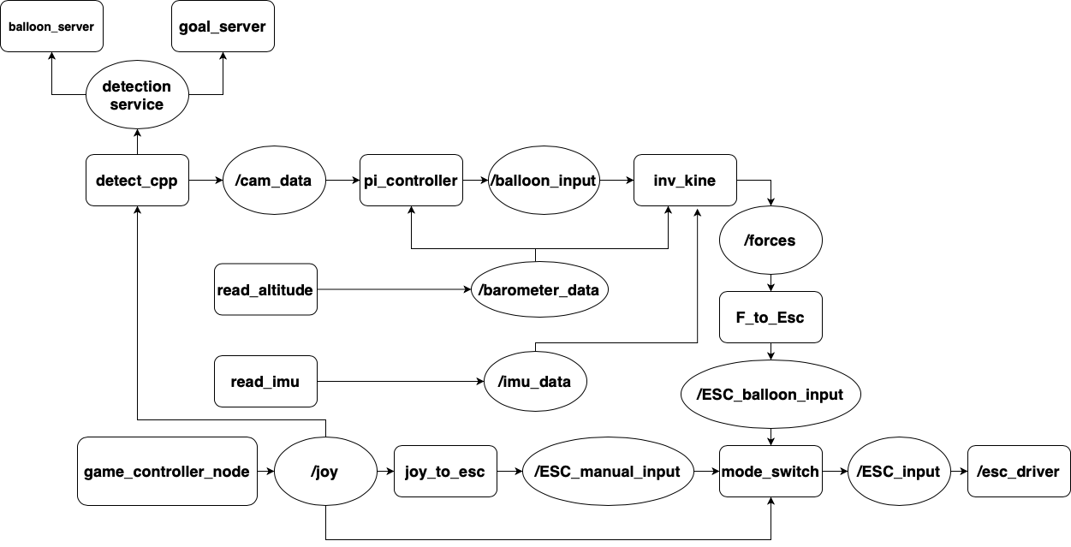

Nodes

detect_client
detect_cpp
Location | wvu_blimps_ros2_src/sensors_cpp/src/detect_client.cpp
File Type | C++
Executable Name | detect_cpp
Dependencies
rclcpp | ROS2 cpp communication package
camera_coord | custom interface from blimp_interfaces to publish the camera coordinates
joy | interfaces from sensor_msgs/msg to subscribe to the /joy topic and read controller inputs.
OpenCV | library for computer vision to for image detection
vector | vector object used for sending camera data
Parameters | None
Subscriptions | /joy
Publications | /cam_data

Description
This node acts as the client node between the balloon_server and the goal_server. Every time this node begins to spin, it will open and begin running the camera. Then, the code will reach two flags that will control what the node will then do with the camera running. the two flags that determine this are the control_mode flag and the cam_mode flag.
The control_mode flag determines whether the blimp is in manual mode or autonomous mode. This can be controlled by the pilot by pressing X on the Xbox controller to switch between modes. When the flag is true, the blimp is in manual mode, and when it’s false, it's in autonomous mode. In manual mode, the frame will not be captured and nothing will be published. In autonomous mode, the frame will be captured into an OpenCV matrix. Then it is converted into a vector to be sent over the service to the proper server nodes.
The cam_mode flag determines which server the frame vector should be sent to. When the flag is true, it is sent to the balloon_server node to complete the balloon_detection. When the flag is false, it is sent to the goal_server node to complete the goal detection.
After the server completes its computation and sends the data back, that contains a boolean hasDetection that determines if the server’s algorithm has a detection, and two integers, x_coord and y_coord, that contain the X and Y coordinates for the center of the detected object. If the hasDetection is true, it will then publish the X and Y coordinates.

balloon_server
balloon_server
Location | wvu_blimps_ros2_src/sensors_cpp/src/balloon_server.cpp
File Type | C++
Executable Name | balloon_server
Dependencies
rclcpp | ROS2 cpp communication package
OpenCV | library for computer vision to for image detection
vector | vector object used for sending camera data
Parameters | None
Subscriptions | None?
Publications | None?

Description
This is a server node used to compute the balloon detection algorithms using the frame sent by the detect_cpp node. This server will use the defined range of HSV values and look for the area with the highest density of those values. The program will then draw a circle around the detected density. If the circle is bigger than the minimum radius of the center coordinates of the circle, it will then prep the data to be sent back through the service to the detect_cpp node. It will set the hasDetection boolean set to true, along with the integers x and y to the detected X and Y coordinates. If the algorithm does not generate a detection, it will then set hasDetection to false and then set the X and Y coordinates to 0.

goal_server
goal_server
Location | wvu_blimps_ros2_src/sensors_cpp/src/goal_server.cpp
File Type | C++
Executable Name | goal_server
Dependencies
rclcpp | ROS2 cpp communication package
OpenCV | library for computer vision to for image detection
vector | vector object used for sending camera data
Parameters | None
Subscriptions | None?
Publications | None?

Description
This is a server node used to compute the goal detection algorithms using the frame sent by the detect_cpp node. We define a set range of HSV values to focus on the colors we need. From there, we find the edges of the color detected using cv2.canny. Using those edges, the openCV method, HoughLinesP, finds probabilistic lines and saves their x1, y1, x2, y2. Using these 2 points, we find the midpoints of the line. Taking the max and min X of the midpoints (meaning the 2 vertical sides of the goal) and the max and min Y (meaning the 2 horizontal sides of the goal) we find the average of those to give us the center of the detected goal. If the algorithm does detect a center of the goal, it will then set the hasDetection boolean set to true, along with the integers x and y to the detected X and Y coordinates. If the algorithm does not generate a detection, it will then set hasDetection to false and then set the X and Y coordinates to 0.

esc_driver
esc_driver
Location | wvu_blimps_ros2_src/controls/controls/esc_driver.py
File Type | python3
Executable Name | esc_driver
Dependencies
rclpy | ROS2 python communications package
EscInput | custom interface from blimp_interfaces/msg for publishing and reading pwm inputs.
Joy | interfaces from sensor_msgs/msg to subscribe to the /joy topic and read controller inputs.
pigpio | library used to change the pwm signals on the specified pins.
os | allows the program to run an command in the terminal
time | used for sleep or getting the local time
subprocess | used to access the bluetooth stuff
Parameters | MAC: import the MAC address of the current controller. Default is 68:6C:E6:73:04:62
Subscriptions | /joy
Publications | None

Description
This program is used to take in an ESC input and apply them to the motors using pigpio. The ESC inputs come from subscribing to the mode switcher.

F_to_esc
F_to_esc
Location | wvu_blimps_ros2_src/sensors_cpp/src/force_to_ESC_input.cpp
File Type | C++
Executable Name | F_to_esc
Dependencies
rclcpp | ROS2 cpp communication package
card_coord | custom interface from blimp_interfaces/msg for publishing and reading cartesian.
esc_input | custom interface from blimp_interfaces/msg for publishing and reading pwm inputs.
Eigen/Dense | for doing matrix math in C++
cmath | for more math functionality in C++
Parameters | None
Subscriptions | /force
Publications | /ESC_balloon_input

Description
This program subscribes to the forces importing from the inv_kine nodes and uses a pseudo inverse method to convert the forces from the blimps body frame to motor inputs.

game_controller_node
game_controller_node
Subscriptions | /joyfeedback
Publications | /joy

Description
This node is from the Joy package install. It is used to read the inputs from the xbox controller and publishes to the /joy topic. For more information please visit the documentation websites. https://index.ros.org/p/joy/

inv_kine
inv_kine
Location | wvu_blimps_ros2_src/sensors_cpp/src/inv_kine.cpp
File Type | C++
Executable Name | dynamic_model
Dependencies
rclcpp | ROS2 cpp communication package
imu_data | custom package
card_coord
baro_data
esc_input | custom interface from blimp_interfaces/msg for publishing and reading pwm inputs.
Eigen/Dense | for doing matrix math in C++
cmath | for more math functionality in C++
Parameters | Rho_air (default=1.225) | Air density is used to find buoyancy of a balloon.
Parameters | Buoyancy (default = Weight of Blimp)
Subscriptions | /imu_data
Subscriptions | /barometer_data
Subscriptions | /balloon_input
Publications | /forces

Description
Uses Information from IMU, barometer, and balloon input to model vehicles state. IMU data includes orientation, angular velocity, linear acceleration. Barometer data is used to approximate vertical velocity. Balloon input is used to determine vertical acceleration and yaw acceleration. This information is run through the dynamic model and forces and moments are published.

Joy_to_esc
joy_to_esc
Location | wvu_blimps_ros2_src/controls/controls/joy_to_esc_input.py
File Type | python3
Executable Name | joy_to_esc
Dependencies
rclpy | ROS2 python communications package
EscInput | custom interface from blimp_interfaces/msg for publishing and reading pwm inputs.
Joy | interfaces from sensor_msgs/msg to subscribe to the /joy topic and read controller inputs.
time | used for sleep or getting the local time
Parameters
Subscriptions
Publications

Description
This program is used to take in an ESC input and apply them to the motors using pigpio. The ESC inputs come from subscribing to the mode switcher.

mode_switch
mode_switch
Location | wvu_blimps_ros2_src/controls/controls
File Type | python3
Executable Name | mode_switch
Dependencies
EscInput | custom interface from blimp_interfaces/msg for publishing and reading pwm inputs.
CameraCoord
Joy | interfaces from sensor_msgs/msg to subscribe to the /joy topic and read controller inputs.
time | used for sleep or getting the local time
Parameters | None
Subscriptions | /ESC_Manual_input
Subscriptions | /ESC_balloon_input
Subscriptions | /joy
Publications | /ESC_input

Description

pi_controller
pi_controller
Location | wvu_blimps_ros2_src/sensors_cpp/src/test.cpp
File Type | C++
Executable Name | pi_controller
Dependencies
rclpy | ROS2 python communications package
cart_coord
camera_coord | custom interface from blimp_interfaces to publish the camera coordinates
baro_data
vector | vector object used for sending camera data
cmath | for more math functionality in C++
Parameters | iheight | initial height of barometer when program starts
Parameters | kpx | proportional gain for yaw acceleration
Parameters | kix | integral gain for yaw acceleration
Parameters | kpyu | proportional gain for vertical acceleration (in the upward direction)
Parameters | kpyd | proportional gain for vertical acceleration (in the downward direction)
Parameters | kiy | integral gain for vertical acceleration
Parameters | x_goal | goal coordinates of camera center, x_center of camera frame (320)
Parameters | y_goal | goal coordinates of camera center, y_center of camera frame (240)
Parameters | kpb | proportional gain for barometer
Subscriptions | /cam_data
Subscriptions | /barometer_data
Publications | /balloon_input

Description
Uses Raspberry Pi camera v2.1 to approximate the center of a target via Hue Saturation Values (HSVs). Based on the x and y directional error between the target and the camera center (goal position). Vertical and yaw accelerations are tuned and sent to the inverse kinematic model.

real_altitude
read_altitude
Location | wvu_blimps_ros2_src/sensors/sensors/barometer.py
File Type | python3
Executable Name | read_altitude
Dependencies
time | Used for sleep of getting local time
board
adafruit_bmp3xx
BaroData
Parameters | sea_level_pressure | pressure at sea level on a given data
Subscriptions | None
Publications | barometer_data

Description
Approximates the current altitude of the blimp in meters based on atmospheric conditions of the day. Barometer used on current system is an Adafruit BMP390.

read_imu
read_imu
Location | wvu_blimps_ros2_src/sensors_cpp/src/inv_kine.cpp
File Type | python3
Executable Name | read_imu
Dependencies
rclpy | ROS2 python communication package
time | used for sleep or getting the local time
board
busio
adafruit_bno055
numpy
math
ImuData
Parameters | None
Subscriptions | None
Publications | /imu_data

Description
Uses an adafruit BNO055 absolute orientation sensor to record euler angles, linear acceleration, and angular velocity that is used in the dynamic model for an estimation of vehicle state.

Defender Blimp (Bomber)

Overview
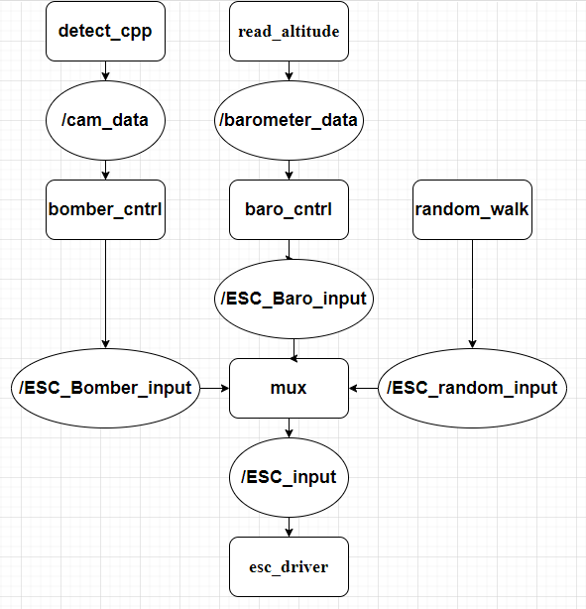

Nodes

baro_cntrl
detect_cpp
Location
File Type
Executable Name
Dependencies
Parameters
Subscriptions
Publications

Description

bomber_cntrl
bomber_cntrl
Location | wvu_blimps_ros2_src/controls/controls/Bomber_Cntrl.py
File Type | python3
Executable Name | bomber_cntrl
Dependencies
rclpy | RPS2 python communications package
EscInput
CameraCoord
Scipy
Numpy
Parameters | None
Subscriptions | /cam_data
Publications | /ESC_Bomber_input

Description
Uses the cam_data topic data to calculate the motor inputs to move the detected object into the center of the camera then publishes the inputs to ESC_Bomber_input

detect_cpp
detect_cpp
Location | wvu_blimps_ros2_src/sensors_cpp/src/detect_node.cpp
File Type | C++
Executable Name | detect_cpp
Dependencies
rclcpp | ROS2 cpp communication package
camera_coord | custom interface from blimp_interfaces to publish the camera coordinates
joy | interfaces from sensor_msgs/msg to subscribe to the /joy topic and read controller inputs.
OpenCV | library for computer vision to for image detection
vector | vector object used for sending camera data
Parameters | None
Subscriptions | /joy
Publications | /cam_data

Description
This node captures a image from the camera everytime it runs. It has two modes detect balloon or detect goal. To change between these either of these modes the pilot needs to press the X button on the Xbox controller. In balloon detection mode, the program will use the defined range of HSV values and look for the area with the highest density of those values. The program will then draw a circle around the detected density. If the circle is bigger than the minimum radius the center coordinates of the circle is sent to to an averaging function. This function will publish the center coordinates every amount of detections we define.

In goal detection, the program works similarly to balloon detection. We define a set range of HSV values to focus on the colors we need. From there, we find the edges of the color detected using cv2.canny. Using those edges, the openCV method, HoughLinesP, finds probabilistic lines and saves their x1, y1, x2, y2. Using these 2 points, we find the midpoints of the line. Taking the max and min X of the midpoints(meaning the 2 vertical sides of the goal) and the max and min Y(meaning the 2 horizontal sides of the goal) we find the average of those to give us the center of the detected goal.

esc_driver
esc_driver
Location | wvu_blimps_ros2_src/controls/controls/esc_driver.py
File Type | python3
Executable Name | esc_driver
Dependencies
rclpy | ROS2 python communications package
EscInput | custom interface from blimp_interfaces/msg for publishing and reading pwm inputs.
Joy | interfaces from sensor_msgs/msg to subscribe to the /joy topic and read controller inputs.
pigpio | library used to change the pwm signals on the specified pins.
os | allows the program to run an command in the terminal
time | used for sleep or getting the local time
subprocess | used to access the bluetooth stuff
Parameters | MAC: import the MAC address of the current controller. Default is 68:6C:E6:73:04:62
Subscriptions | /joy

Description
This program is used to take in an ESC input and apply them to the motors using pigpio. The ESC inputs come from subscribing to the mode switcher.

random_walk
random_walk
Location | wvu_blimps_ros2_src/controls/controls/random_walk.py
File Type | python3
Executable Name | random_walk
Dependencies
rclpy | ROS2 python communication package
EscInput
random | package to generate pseudo random numbers
Parameters | None
Subscriptions | None
Publications | /ESC_random_input

Description
uses the random library to generate a random input for a motor and then publishes it to ESC_random_input that lasts for 2 seconds then it generates a random input.

bomber_mux
bomber_mux
Location | wvu_blimps_ros2_src/controls/controls/bomber_mux.py
File Type | python3
Executable Name | mux
Dependencies
rclpy | ROS2 python communication package
EscInput
time | used for sleep or getting the local time
Parameters | None
Subscriptions | /ESC_Bomber_input
Subscriptions | /ESC_random_input
Subscriptions | /ESC_baro_input
Publications | /ESC_input

Description
It subscribes to the ESC_Bomber_input, ESC_random_input, ESC_Baro_input sets the height control based off of baro_input then decides whether to use the random walk motor inputs or the bomber input based on the time from the last detection. If it is in bomber mode it will wait 10 seconds from the last inputs then if it hasn't changed by then it switches to random walk. If it is in random walk it will switch back to the bomber control if the bomber inputs change.

read_altitude
read_altitude
Location | wvu_blimps_ros2_src/sensors/sensors/barometer.py
File Type | python3
Executable Name | read_altitude
Dependencies
time | Used for sleep or getting the local time
board
adafriut_bmp3xx
BaroData
Parameters | sea_level_pressure | pressure at sea level on a given day
Subscriptions | None
Publications | /barometer_data

Description
Approximates the current altitude of the blimp in meters based on atmospheric conditions of the day. Barometer used on current system is an Adafruit BMP390

